1. **User Acceptance Test (UAT)**

**User Acceptance Test Procedures**

User Acceptance test procedure defines the whole process that is required to make any software or application user acceptable. There are some specific steps that we performed while

Completing User Acceptance Test procedure. These are:

1. **Analysis of Requirements**
2. Charter
3. Use Cases
4. Flow diagram
5. BRD (Business Requirement Document)
6. SRS (System Requirements Specification)
7. **UAT (User Acceptance Test) Plan creation.**
8. Entry Criteria for UAT
9. Exit Criteria for UAT
10. Test Scenario approach
11. Test cases approach
12. Testing Timelining
13. **Test Scenarios Identification**
14. **Creation of UAT (User Acceptance Test) cases.**

Business Use cases are used as an input for producing the various test cases.

1. **Preparing Test data**
2. **Test Run and recording results**
3. Executing test cases
4. Finding bugs
5. Re-testing of fixed bugs
6. **Confirm that whether business goals are achieved or not.**

To check that whether the product (software, application, etc.) is acceptable or not. Following deliverables are used to check the business goals.

1. Test Plan
2. UAT Scenarios and Test Cases
3. Test Results and Defect Log

**Overview**

**System name:** “Borrow a Book.”

**Purpose**

1. The purpose of the UAT is to provide the acceptance testing for the “Borrow a Book” to verify compliance with the system requirements.
2. To ensure that all the system requirements for the “Borrow a Book” are appropriately provided through user acceptance test.

**Scope**

The scope of this UAT (User Acceptance Test) is to explain that all the requirements that were necessary for the “A borrowed book” library system has been satisfied.

**Output**

1. It is required that the system will work appropriately. When the borrower requests various use cases, then it must function according to the requested use case.
2. User Acceptance Test will help to decide the various changes required in the system.

**Testing**

**Unit Testing**

* Unit testing of the program was the responsibility of the programmer.
* For both modules “BookDAO.java” and “Member.java” a set of standard test was established.
* For both modules, a set of test cases or test conditions were established that included all the possible situations and errors.
* It was undertaken in an environment that was located on the server used for development.
* For all modules, we defined the expected results as well as test results.

**Use Cases**

|  |  |  |
| --- | --- | --- |
| Sr. No. | Actors | Use Cases |
| 1. | Borrower | Borrow book |
| 2. | Borrower | Return the book |
| 3. | Borrower | Borrowing Multiple Books |

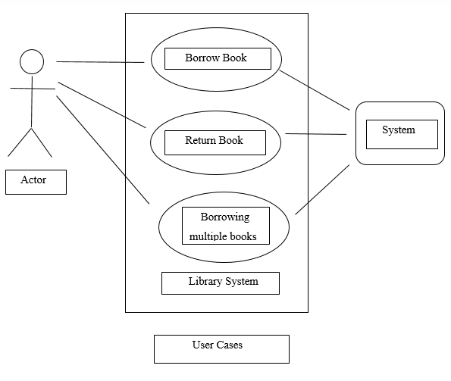

Fig. Use Case

**Expected and Test Results**

|  |  |  |  |  |
| --- | --- | --- | --- | --- |
| **No.** | **Expected Results** | **Critical** | **Test Result** | **Comments** |
| 1 | The system allows the user to swipe the card. | Yes | Accepted | Worked in the first test. |
| 2 | The system must enable the card reader. | Yes | Accepted | Worked in the first test. |
| 3 | System retrieves the borrower information appropriately | Yes | Accepted | There were some problems in the code. But after correction, the second run achieved desired results |
| 4 | The system displays every required message. | Yes | Accepted | Was working appropriately in the first test. |
| 5 | The system must enable the scanner whenever required. | Yes | Accepted | The system performs this function very well. |
| 6 | The system must retrieve the book detail correctly. | Yes | Accepted | Required results achieved after the third test. |
| 7 | The system checks for the loan of the students. | Yes | Accepted | Work appropriately. |
| 8 | All the calculations in student loan list must be done appropriately. | Yes | Accepted | Work appropriately. |
| 9 | The system disables the scanner whenever required. | Yes | Accepted | Work appropriately. |
| 10 | The system should print borrowing slip. | Yes | Accepted | Different messages were printed wrong in the two attempts. Changes in the code made the system correct. |
| 11 | Must show the restriction message if the user is not eligible for borrowing the book. | Yes | Accepted | Work appropriately. |
| 12 | The system must allow the borrower to scan more books if they want. | Yes | Accepted | Work appropriately. |

We checked all the codes using different parameters and tested that. The Code is defined in a user-friendly manner.

**System name:** “Add a Book.”

**Purpose**

1. The purpose of the UAT is to provide the acceptance testing for the “Add a Book” to verify compliance with the system requirements.
2. To ensure that all the system requirements for the “Add a Book” are appropriately provided through user acceptance test.

**Scope**

The scope of this UAT (User Acceptance Test) is to explain that all the requirements that were necessary for the “Add book” library system has been satisfied.

**Output**

1. It is required that the system will work appropriately. When we call the function of add book with required parameters, the book is added successfully.
2. Appropriate messages are displayed to inform the user about the function being performed.

**Screenshots**

